**SELECT * AND SPECIFIC COLUMNS AND APPLYING WHERE,AND,OR,BETWEEN, LIKE**

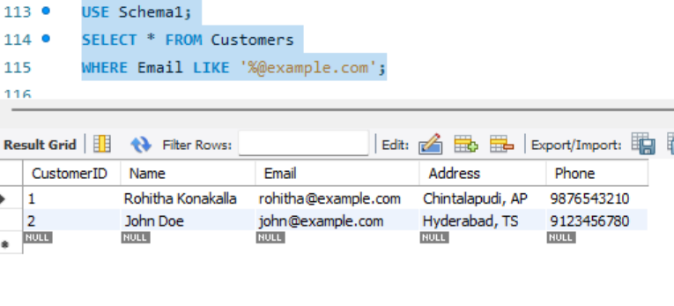

**ORDER BY**

